**National University of Computer and Emerging Sciences**

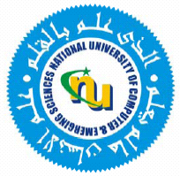

Laboratory Manual 05

for

Data Structures Lab

|  |  |
| --- | --- |
| Course Instructor | Mr. Uzair Naqvi |
| Lab Instructor(s) | Ms. Maryam Rehman  Ms. Marwa Khan |
| Section | BCS-3B |
| Semester | Fall 2022 |

**Department of Computer Science**

FAST-NU, Lahore, Pakistan

**Objectives:**

In this lab, students will practice:

1. Recursion
2. Write the Recursive
   1. BinarySearch and test it on huge Data.
3. Write a Program in which you compute A/B and A%B and the only operations allowed are subtraction and addition.
   1. The algorithm must take O (B) times additions/subtractions.

1. Write the recursive and iterative code for Fibonacci number computation.
   1. Analyze why Iteration is working so fast as compared to the recursive implementation of Fibonacci Numbers.
2. Write the recursive and iterative code for computing the Tri-Sum sequence: 1, 2, 3, 6, 11, 20, 37…
   1. Write the recursive mathematical formulation.
   2. Write the recursive code for the Sequence generator
   3. Analyze what will be its time complexity (the approximate number of times the recursive call will be called.